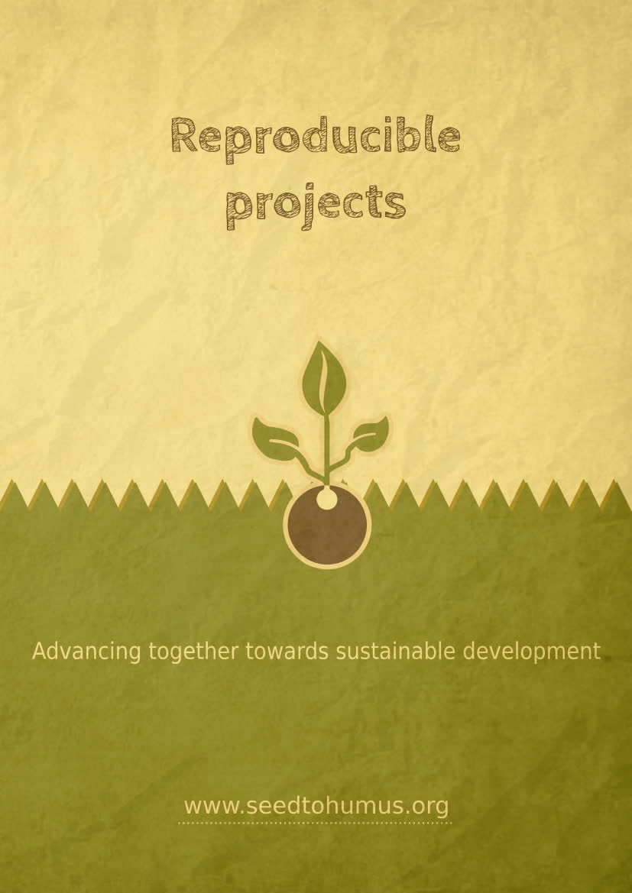
Table of contents
Foreword 1
Licenses 2
Introduction 3
1. Free shop 4
2. DIY Cleaners 4
3. Animal habitats 5
4. Screening of copyright-free films 5
5. Homemade and reuse 5
6. Low impact picnic 6
7. Garden sharing 7
8. Collective composting 7
9. Book box 7
10. Giving box 8
11. Fruit and vegetable box 9
12. Making games 10
13. Linux computer repair 10
14. Repair workshop 10
15. Moss graffiti 11
16. Children’s books 11
17. Gender 11
18. Recovery 12
19. Reuse of plastic bags 13
20. Cardboard furniture 16
21. Language course 19
22. Ground soil analysis 24
23. Garden Tips 25
24. Participatory mapping 25
25. Accessibility map 26
26. Draw your city 26
27. Treasure hunt 26
28. Expériences scientifiques 27
29. illusions of the senses 28
30. A meal in the dark 28
31. Tools and materials 29
32. Seed library 29
33. Shared gardens 30
34. Seed bomb 30
35. The map of possibilities 30

Foreword
The purpose of this document is to become a collaborative resource for social and environmental projects.
To stop saying "but what can we do about it?", we present social or environmental actions that are reproducible, local and often require few resources and skills to implement them.
This document does not cover the communication, partners, resources, volunteers and implementation aspects which are also important to identify so that everyone is there on the event and in the best possible conditions.
You say, “That thought is mine.” No my brother,
It is in you, nothing is ours.
Everyone has had it or will have it. Reckless kidnapper,
In the common domain, far from subtracting it,
Make it like a deposit : Sharing is so sweet !

Henri-Frédéric Amiel, Nothing is ours
This work is open to completeness and coherence in a collaborative manner.

≈ This document is certainly imperfect, incomplete and may contain errors. Please contact us at bonjour@graineahumus.org to participate in the improvement. ≈

Find the latest version at www.seedtohumus.org.

Licenses
The written content of this document is licensed under CC0.
The CC0 license allows anyone to freely reuse, improve, and modify this work for any purpose without any legal restrictions, except those imposed by law.

The document is made with Libre Office (Mozilla Public License) and Inkscape (GNU GPL).
The fonts used are Cabin Sketch (SIL Open Font License) and DejaVu Sans (Public Domain).
Font Awesome icons on the cover are licensed under SIL OFL 1.1, CC BY 4.0 (https://fontawesome.com/).
~~~
Version 1 (March 2025) by Ben LARCHER, member of the association “From seed to humus”.

Introduction
The aim of this booklet is to provide, to as many people as possible, ideas for local social or environmental actions, whether you are an association, a social center, ordinary citizens, a municipality, etc.
Of course, there are environmental and social emergencies to be addressed at a higher level (institutions, businesses, etc.), however, in parallel, we can act at our level!
This can be done with sociocultural centers, formal or informal collectives, associations, retirement homes, whatever the form, institutional or not.
Sometimes all you need is a place to meet as a collective and act by and for citizens (a large room, a shed, a squat, a large house, outside, etc.)
This document is primarily intended to focus on reproducibility and participation!

Free shop
Donation of miscellaneous items.
The principle is simple. We meet on a date, in order to give away the objects that we no longer need.
A bit like a garage sale, except that everything is free.
Objects that are not donated following the event can then be distributed to social organizations or associations.
It is important to communicate on the fact, even to verify, that what is brought is in good condition. The aim is not to be a deposit for the recycling center.
It is possible to combine this with a thematic day, such as a zero waste picnic, exhibitions or documentaries on the waste theme... Or even a pleasant moment with a concert or recreational activities...

DIY Cleaners
Sharing recipes and tips.
Do you have any homemade cleaning tips?
Whether for economic or ecological reasons, there are good reasons to make your own cleaning products.
Sharing tips, finding new resources, sharing a common interest is a good way to go forward the environmental cause, while saving money and paying attention to our health.
You will find plenty of resources on the web to experiment with others !

Animal habitats
Build habitats to help local wildlife.
Identify local animal species, in order to build a habitat for them.
You can also make seed fat balls to help the birds overwinter.
Resources
https://habitat.graineahumus.org
You can also contact a local association, expert in the field, to seek advice, or even to participate.

Screening of copyright-free films
Promote copyright-free works.
Broadcast a copyright-free work is legal.
It can be works that have fallen into the public domain, such as Buster Keaton’s films, or modern works placed in copyleft, such as documentaries, movies by Nina Paley or animated movies from the Blender Institute.
You can also take the opportunity to talk about free culture and copyright issues.
A resource website with copyright-free films (and other resources)
https://www.libresites.org/
Exhibition on free software and free culture
https://www.graineahumus.org/libre-exhibition

Homemade and reuse
Your tips to throw less or produce less.
A craze for homemade is growing. In addition, specialized websites are often into reuse.
Doing it yourself means understanding, learning and not having a consumer relationship with an object. It’s also knowing how to fix it.
Many projects await you on the web!
The global reference site
https://www.instructables.com/

Low impact picnic
Reduce its environmental footprint.
During an environmental event, a low-impact picnic can serve as a medium for exchanging information.
Indeed, food has a strong impact on the environment. Thus, in the richest countries, the environmental footprint is about 4 (It would take 4 planets for our children to have the same resources as us).
Among the elements that one can implement for a low impact picnic, one can make a picnic with the following criteria:
- zero waste;
- vegetarian, vegan or avoiding high-impact meat;
- From the less “noble” parts;
- local and seasonal.
Picnic recipes can be collected beforehand, in order to be shared during the event.
Having a good time is the best way to share tasty recipes, discover new tastes, and thus, change your habits with pleasure.

Garden sharing
A link to the earth.
An unoccupied space, even of modest size, can become a shared garden.
Raised bins can allow access for people in wheelchairs or the elderly who can no longer be in direct contact with the ground.
For older people, it can also create an intergenerational link, by explaining things to younger generation.

Collective composting
Reduce waste and generate social connections.
An unoccupied space, even of modest size, can become a collective composter.
Almost a third of our waste is compostable waste.
We can reduce our waste, while returning elements to the earth, promoting a local ecosystem and generate social connections.
For this, a collective composter is a very effective tool.
Resource
https://compost.graineahumus.org

Book box
Make the books travel!
A book box allows you to share books that you enjoyed.
The box can be indoors or outdoors (which requires a suitable material like an outdoor wood). For outside boxes, maintenance every 2/3 years may be required.
An agreement with the local library may allow new books to be added to the box.
A poster on the side can explain the operation. We take a book and we can bring it back or bring another one that we want to share.

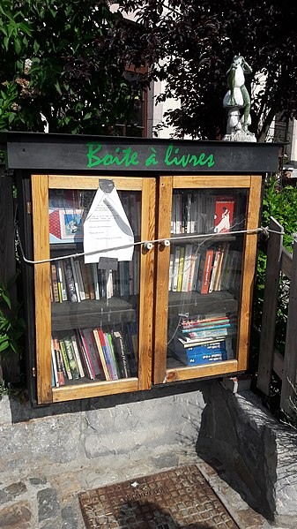
Photo : Jakka Jakka, Creative commons BY SA

Giving box
Share to produce less.
A giving box allows you to share objects that you no longer use.
The box can be indoors or outdoors (which requires a suitable material like an outdoor wood). For outside boxes, maintenance every 2/3 years may be required.
A poster on the side can explain the operation. We only give objects in good condition, it’s not for the recycling center. Everyone can help themselves.
Objects that are not donated after a certain period of time can then be distributed to social organizations or associations.
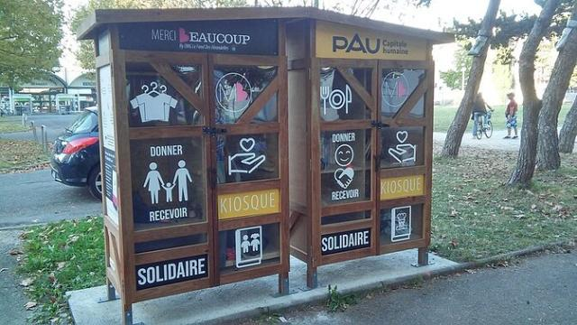
Photo : Hamuli, Creative commons BY SA

Fruit and vegetable box
Share the extra vegetables and fruits.
Ideal when you have a collective garden and the harvest exceeds the needs.
We can then put the extra fruits and vegetables in a box.
The box can be indoors or outdoors (which requires a suitable material like an outdoor wood). For outside boxes, maintenance every 2/3 years may be required. Outside, plan to put in the shade for a longer conservation.
A sign (a raised flag or other) can be provided when the box is full.
A poster on the side can explain the operation. We only give fruits and vegetables in good condition. Everyone can help themselves.

Making games
Make games yourself.
Awale, tic tac toe, mölkky, skittles, board games... You can make them yourself in wood, cardboard, clay, 3D printing, papier mâché...
Be careful to respect copyrights (which will concern only the most “modern” games).

Linux computer repair
Free yourself and extend the life of the computer.
When you have somewhat old computer hardware, out of order, or you want to get out of the proprietary system and mass surveillance, it is possible to switch to Linux.
This requires the presence of people who know about it and can train others.

Repair workshop
Extend the life of objects.
With a few handymen on hand, you can set up repair or co-repair workshops.
The best is when the people who bring an object handle the tools themselves and thus become more autonomous.
There is also a network to which it is possible to join, the “repair cafés”.
Resources
https://www.repaircafe.org/en/
The repair café website
https://www.ifixit.com/
Over 80,000 tutorials
https://www.sosav.fr/
Repair computer equipment, game console, smartphone...

Moss graffiti
A bit of nature on concrete.
Moss graffiti consists of spraying moss on a wall to create an artwork.
Recipe, advice and examples
https://www.instructables.com/How-to-Make-Moss-Graffiti-1/

Children’s books
Get out of stereotypes.
Tired of redneck heroes, assisted princesses and other stereotypes in children’s books?
What if you wrote the stories yourself and shared them?
Resource
https://www.graineahumus.org/stories-to-share-85

Gender
Questioning gender at any age.
Gender is the social assignment of a person by their sexuation. This leads to stereotypes like “Girls are sweet” or “Boys are bullies”. Over time, stereotypes change.
Resource
https://www.graineahumus.org/gender

Recovery
Recover and reuse.
We live in a society where a lot of waste is generated. With reuse, waste can become new raw materials.
If we have space, we can then recover. Recover what? Bread, food, wood, scenographies...
Via a search on the internet, we can look at ways to reuse such and such things. Many things can be salvaged.
The idea being to identify where the resources are and how to reuse them.
Be careful not to recover final waste that will encumber!
Here are some examples, but you can find many more!
Where to recover | What | How to reuse
Bakery | Bread | Make grist, grind bread and make new recipes, make breadcrumbs...
Company | Computers | Linux Refurbishment
Company | Office equipment | Office equipment with possible makeover
Company | Cardboard | Cardboard Furniture
Performance hall, Conventions, Congresses & Expos | Scenographic elements | Scenographic rehabilitations
Parks and gardens maintenance, gardening business, sawmill | Plants when renewing the bed, cuts, shredded material | Plants, mulching, Ramial Chipped Wood, supply for dry toilets or composter with the shredded material...
Eco-friendly construction company | Wood scrap | Habitat for bird, insect, hedgehog, bat...
Vegetables | Spoiled vegetables and fruits | Animal food, compote, soup, recipes to eat quickly...

Reuse of plastic bags
Reuse plastic bags (polyethylene).
Please note, this only works with plastic bags (polyethylene, HDPE or LDPE, i.e. high or low density polyethylene).
Some plastics are thermoplastics and can reform with heat. Polyethylenes are one of them and do not give off toxic fumes during fusion.
The fusion method
- We put several layers of polyethylene plastic bags on top of each other (recut if necessary).
- We place parchment paper above AND below.
- Thus, we can, with an iron, fuse the plastics, by passing it very hot on the parchment paper.
The knitting method
- We make plastic strips as shown below.
- We knit or crochet with.
Strip cut

By cutting this way, you end up with a single, long, thinner piece.
We can then make wallets, coats, solid bags... according to our imagination.
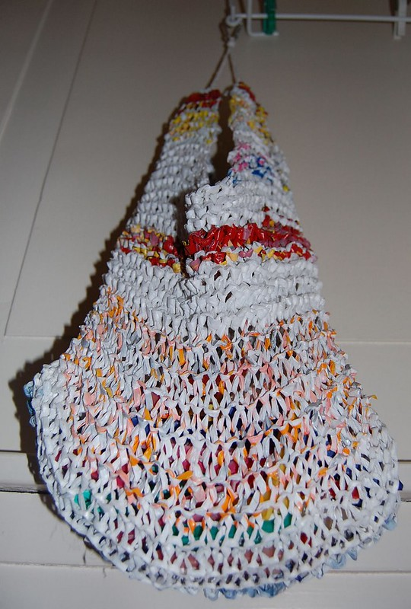
Photo : Audrey, CC BY NC SA. Plastic knit.

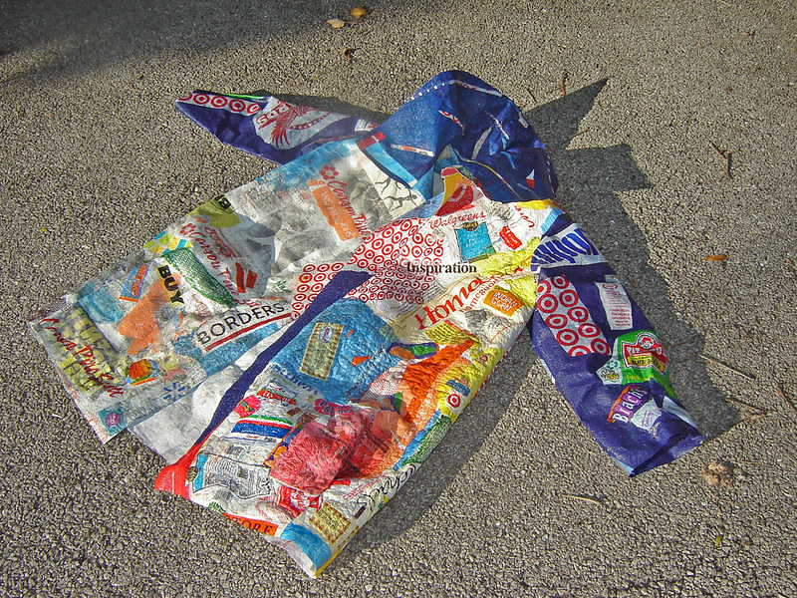
Photo : Mary Anne Enriquez, CC BY NC ND. Plastic fused.

Cardboard furniture
Make your own furniture.
With cardboard, you can make aesthetic and cheap furniture.
Tutorials
A shelf. (License CC BY)
https://www.youtube.com/watch?v=-OMd7NDahOE
A wall shelf. (License CC BY)
https://www.youtube.com/watch?v=dKqa2i0EMUk
A wardrobe. (License CC BY)
https://www.youtube.com/watch?v=Z_U1RUuiNuA
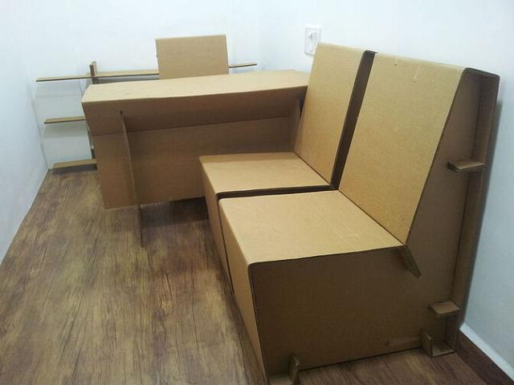
Photo : Ambrishraja, Creative commons BY SA

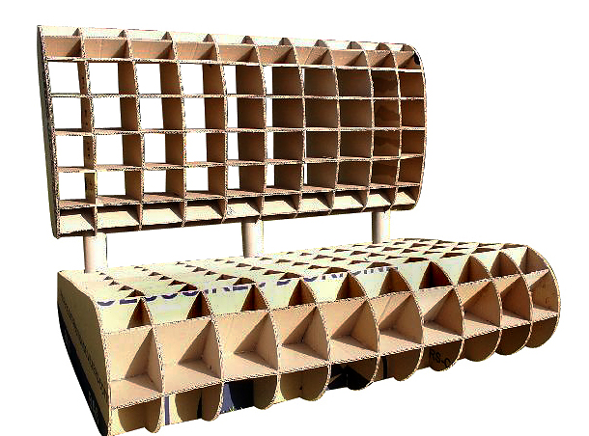
Photo : Gilboonet, Creative commons BY SA
A stage of the construction.

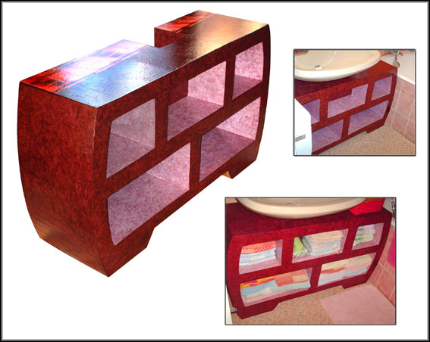
Photo : Gilboonet, Creative commons BY SA
Finishing done.

Language course
Sharing support for learning a language.
It is common to make media, but it is rare to find them on the internet in free sharing.
Drawings are often used, but these are not often under free licenses, so they can hardly be shared.
What if we made it available to everyone?
Media Sharing
In order to share documents containing visuals, here are sites with free licensed visuals. Attention, in some countries, you must cite the source (author if known or site of origin):
https://pixabay.com/
https://www.freepik.com/
https://publicdomainvectors.org/
Sharing methodologies
In all the examples shown, we never translate. We can explain from other known elements, but we don’t translate, we keep talking in the language to be learned.
First of all, we practice, if there are errors (conjugations, spellings), we do not mention the frustrating and complex rules right now. The goal is to have fun, to learn to communicate. Conjugation, grammar, spelling only happens later, when the pleasure is there and you see the result of learning (being more independent, being able to ask something in the street, etc.)
Brief pauses are taken every 30 to 45 minutes, as the methods require a lot of cerebral attention.
Active Learning
Active learning works at any age. We include learners in physically active methods, in order to solicit several modes of learning, while
being fun. We get rid of pencils and papers the time we apply the methods to be fully in the learning session.
Example 1: expanding vocabulary and describing new things
For a language, knowing the shapes, objects, materials, colors, textures... is important, because it allows to describe an object when we do not know it and thus we learn a new word while practicing what we have already learned.
In a group, we introduce a “speaking object” (a foam ball, a stuffed animal...). Only the person who has this object can speak. The person giving the lesson begins by pointing to an object and naming it (or a shape, material, color, texture, depending on the theme). Then this person passes the “speaking object” to someone.
This person points to the previously indicated object and names it, then adds a new object by pointing to it and names it. If she does not know the name of the object, she can ask the person giving the course. Then, she gives the speaking object to a new person.
The advantage is multiple. People who do not know when they are being passed the “speaking object” are attentive. At first, it is difficult to remember more than 5 to 7 words, then it increases the memory. Over time, it’s no wonder it goes to 20 words or even more.
For languages ​​like French that have a masculine and feminine, it is possible to point with one finger when it is a masculine noun and the other for a feminine noun.
— -
You can adapt for verbs by mimicking the verb you are saying or with personal pronouns (I, you, he, she, we, we, you, they, they) by pointing to people.
Example 2: working on descriptions, for people with a little vocabulary
In a group, we introduce a “speaking object” (a foam ball, a stuffed animal...). Only the person who has this object can speak.
The person speaking describes an object by its shape, color,
texture, use, context... The others have to guess what it is.
The speaking object is then passed to another person (not necessarily the person guessing, because otherwise only the “best” are practicing).
Example 3: using symbols with hands
It is possible to use a panoply of symbols to “talk with the hands”.
Above, Below, Beside, Inside, Outside, Front, Behind
You can punctuate these different notions with your hands. They can also be explained with drawings.
You can also take an object and show it by placing it above or below and mentioning it orally.

X  above  ABOVE | X  below  BELOW
X  on  ON | X  beside  BESIDE
X  inside / in  INSIDE / IN | X  outside / out  OUTSIDE / OUT
X  In front  IN FRONT | X  behind  BEHIND

Once the words have been learned, we can do a speed game where the person giving the lesson takes an object and places it relative to a box and the group indicates which position it is.
In the same way, we can have the concepts like before, earlier, here, elsewhere, now, later, after, present, past, future, yesterday, tomorrow...
Example 4: situational learning
Via the methods indicated here (no paper or pencils, setting aside grammar, spelling, complex conjugation, not correcting all errors, the use of gestures and recreational activities...), one can make setting up.
Example to introduce yourself.
Person giving the course: reaches out and say “hello”.
Person taking the course: must say “hello”. (We repeat “hello” if this is not done)
Person giving the course: reaches out, says “hello” and then “my name is...” while pointing itself with the other hand.
Person taking the course: must do the same. (We repeat slowly if this is not done)
Person giving the course: reach out, say “hello”, say “my name is ...” while pointing itself with the other hand, make a “bridge link” with this same hand towards the other person and say “AND” then points the other person “your name is...”
Person taking the course: must do the same. (We repeat slowly if this is not done).
If there is a learning group, they are signaled to turn around the room, rehearsing the scene with each other.
It doesn’t matter what “my name is” means, it’s more important to know that it’s what you say in this context.
Once the terms have been assimilated, you can add new ones like “Hi” (by making a wave with your hand), or by saying “I am...” for your name or your job...

You can do the same kind of exercise (always with gestures, even accessories) for a store, a bar, a restaurant.
Example 5: mentioning mistakes while keeping it simple and positive
If a person is understandable, it is already very good, even with errors. Some language are a complex and few people master it, even among native speakers. Imagine that you are not in a new country by a full choice, that your language is built totally differently or that the alphabet has not the same letters or even the same writing...
If a person manages to make itself understood, but makes small mistakes, then we can do so.
Person learning: “Peter has a beautiful hause”
Person giving the course repeats: “Good! Peter has a beautiful house” without insisting too much on the pronunciation.
Example 6: learning to count to 10
Show the first 5 digits with your fingers.
Then, we show a certain number of fingers (not necessarily adjacent) while waiting for an answer. One can also knock a certain number of times on a table or other similar process.
We change the person who questions at each turn.
We can go over time to 10 digits.

Ground soil analysis
How does the ground soil work?
Many of the things around us come from the ground soils. But how to understand soils in their diversity?
Attention, we are dealing here with the ground soil itself. The soil is a medium and serves as a support, an intermediary for other things. Among other things, we cannot neglect the living without which the soil would not be structured in this way. Although this part does not speak of the living, it is essential.
Resource
https://www.graineahumus.org/ground-soil-analysis

Garden Tips
To follow up on the soil analysis.
This project follows the soil analysis. It is therefore advisable to see it before, but it is not mandatory.
It combines advice and free videos.
For the garden, we will consider the following elements:
• knowledge of the soil
• contributions
• cultivation on soil not adapted to what we want
• what helps a culture
• the development of biodiversity
Resources
https://www.graineahumus.org/soil-and-garden

Participatory mapping
Map around you!
Open street map allows you to map many elements close to home.
Resource
https://www.openstreetmap.org
This map is collaborative and there is a whole community that can help you: https://openstreetmap.community/

Accessibility map
Map places that are wheelchair accessible.
Wheelmap is easy to use and allows you to quickly map wheelchair accessible places.
Resource
https://wheelmap.org/

Draw your city
What places are important to you? What was your journey?
On UMAP, you can add elements that are not permanent or of no interest to everyone (otherwise, we will favor open street map).
If UMAP can have many uses (a hiking route, locations for an event...), we can appropriate it very personally, by tracing areas, paths or by putting commented markers on a map retracing our life, the places important to us…
Resource
https://umap.openstreetmap.fr/en/

Treasure hunt
Organize a scavenger hunt in our city.
Creating a treasure hunt can bring a lot of things (in addition to fun).
This can allow you to get to know your city better or to generate links with the people with whom you participate.
The principle
There is a starting point, with a context, a story.
We can have a document which once completed will take us to the place of the treasure (but the forms can be various).
We play with clues that will be found following the resolution:
- of an enigma
- of a charade
- of a rebus
- of a photo puzzle with a clue
- of an anagram
- a secret code (can be done with an anaglyph message, an encrypting alphabetic text, a Caesar wheel,...)
You can also take inspiration from what is found in “escape games”.
A little research on the internet will bring you plenty of leads!
In order not to get stuck, we can also give clues if necessary.
Occasional or permanent
If the treasure hunt is done on an event, having volunteer “actors” makes the game livelier.
In the case of a permanent treasure hunt in a city, the treasure will be in a weatherproof box. The principle is that if we take the treasure, then we deposit another one.
Remark
We can have different indices depending on the age of the participants.
Vigenère cipher
https://en.wikipedia.org/wiki/Vigen%C3%A8re_cipher

Scientific experiments
For children, but not only...
Experiments to reproduce.
Resources
https://www.goodhousekeeping.com/life/parenting/g32176446/science-experiments-for-kids/
https://www.sciencefun.org/kidszone/experiments/

illusions of the senses
Should we always trust our senses?
Our senses allow us to perceive the world around us. Through the information they bring to us, it participates in the creation of our own conception of the world.
Can our senses deceive us and thus lead us into false perceptions?
Below are classic examples towards optical illusions, but looking deeper, one can also find taste, tactile, olfactory illusions...
Optical illusions
https://en.wikipedia.org/wiki/Optical_illusion
https://www.optics4kids.org/optical-illusions
https://www.amnh.org/explore/ology/brain/optical-illusions-and-how-they-work
https://www.rd.com/article/optical-illusions/
Taste illusions
https://mnestrud.medium.com/gustatory-illusions-cognitive-collusion-1595cb6f7bfe

A meal in the dark
Recognize without seeing...
A meal in total darkness can allow you to think about several topics depending on the approach. These can be the dominance of the visual sense, disability awareness or purely playful.
We can combine the meal, within an event, with « fake news » or with optical illusions with a more general theme on our perceptions and the biases they imply.
It’s also a « social time » when it’s nice to meet people without seeing them !
Remarks
Simple foods in small quantities for each food can multiply the game of taste recognition.
It will be necessary to provide thick and dark sheets and good gaffer type tape, to block out all the light from the windows.

Tools and materials
Pooling of tools and materials.
An extra square, duplicate screwdrivers?
If you’re not a handyman or you don’t have space, putting it aside can be of quite limited interest...
A pooling in a local, allows to deposit what does not serve us and to take what can be useful!

Seed library
Conserve and swarm seed species.
The conservation of natural seed species is a major challenge for biodiversity.
In order to swarm as much as possible, there are seed libraries.
These are boxes that are used to give seeds or to recover them.
A site dedicated to the subject
http://seedlibraries.weebly.com/
Plans for laser cutting manufacture of a seed library and a bag model
https://fabmanager.csc49.fr/#!/projects/grainotheque

Shared gardens
Provide unused gardens.
It is a question of identifying people who are no longer able to take care of their gardens and people who would like to take care of one, but who have no land.
The interests are multiple:
- knowledge sharing;
- the social connection;
- food production...
The places identified available can be mapped on a site like uMap http://umap.openstreetmap.fr/en/
A provision agreement is made and let’s go!

Seed bomb
Bombard the city with seeds to make it green again!
How to make seed bombs? The details are in the video!
Resource
https://www.youtube.com/watch?v=EOqI7yVNuEQ

The map of possibilities
Collaborative map that highlights the actions on a territory.
Presentation and infographics.
Resources
https://www.graineahumus.org/the-map-of-possibilities
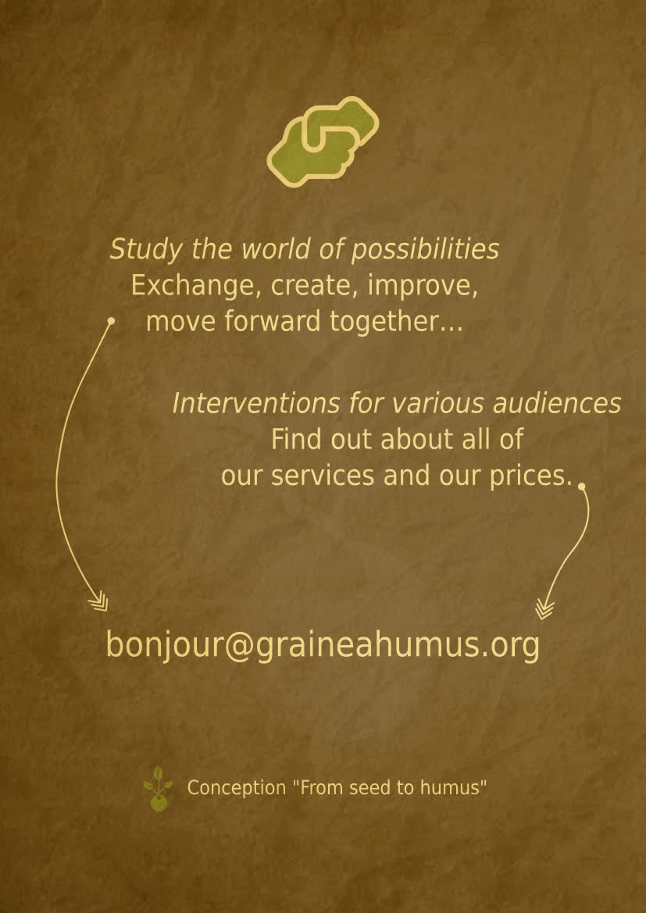

1 kg of beef is equivalent to an emission of 27 kg equivalent CO2, less than lamb (39 kg eq. CO2), but 2 times more than pork (12.1 kg eq. CO2), and 4 times more than chicken (6.9 kg eq. CO2). (source : INRAE, a French institute).

